**Department Application** :

Step:1 Access depart page url: <http://localhost:8080/DepartmentApp/krams/main/record/list>

[Create new Department](http://localhost:8080/DepartmentApp/krams/main/record/add): Fetch all departments are available into the database.

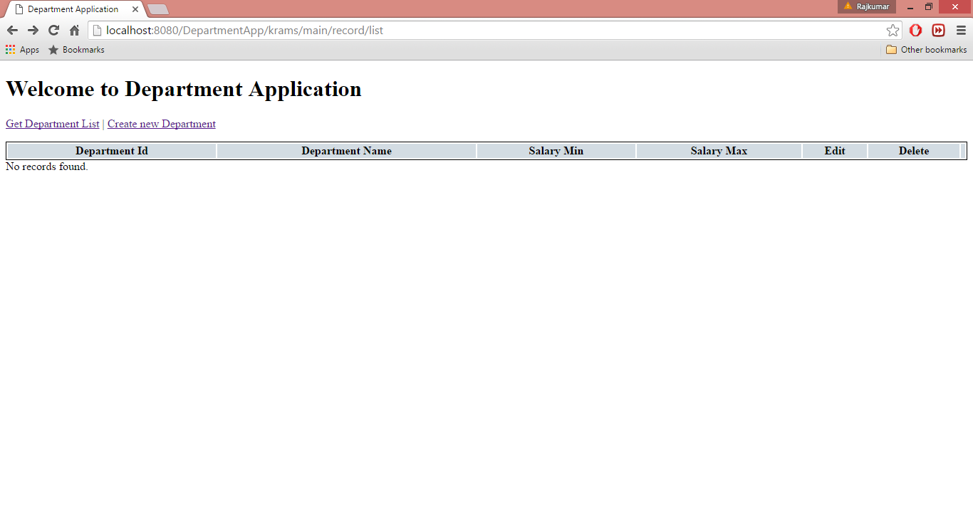

Step:2 Select Create new Department link and you will see below screen to add new department.

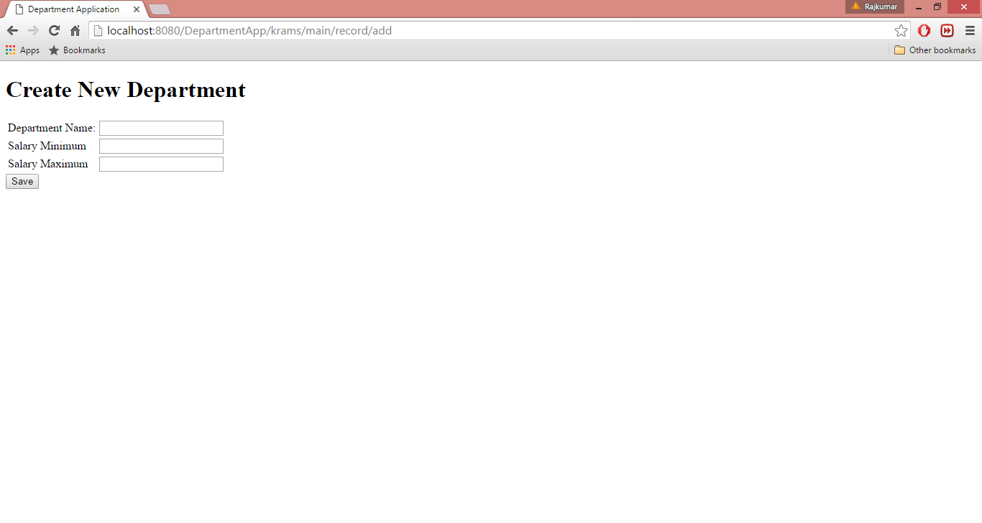

Step:3 Add required fields.

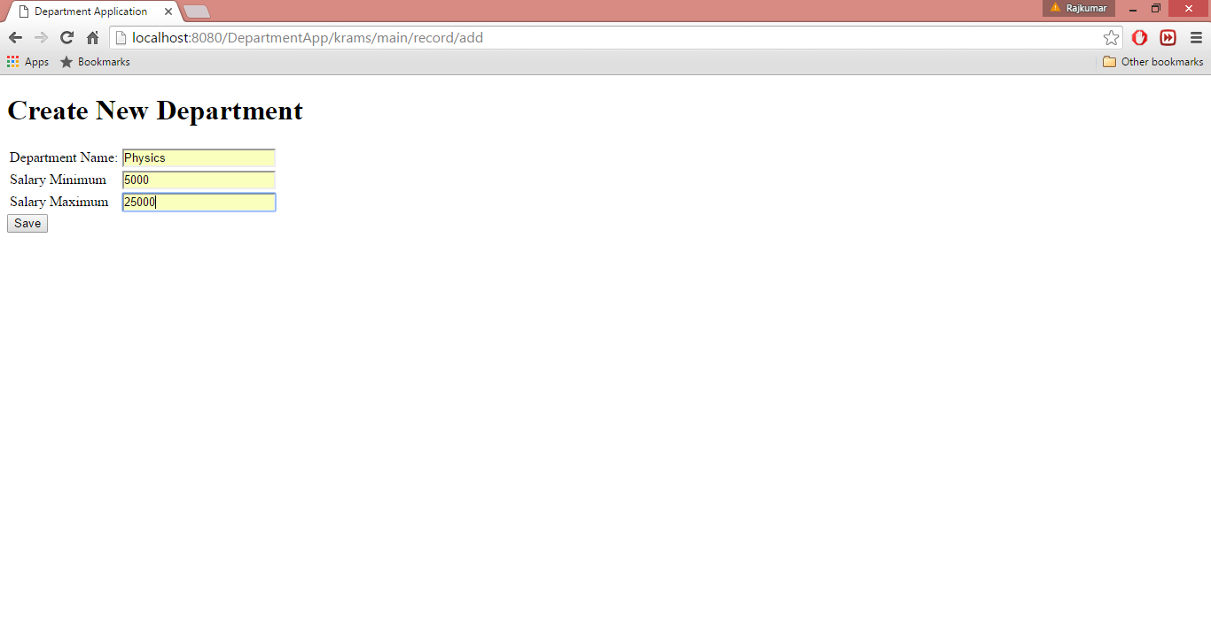

Step:4 Added record on department screen.

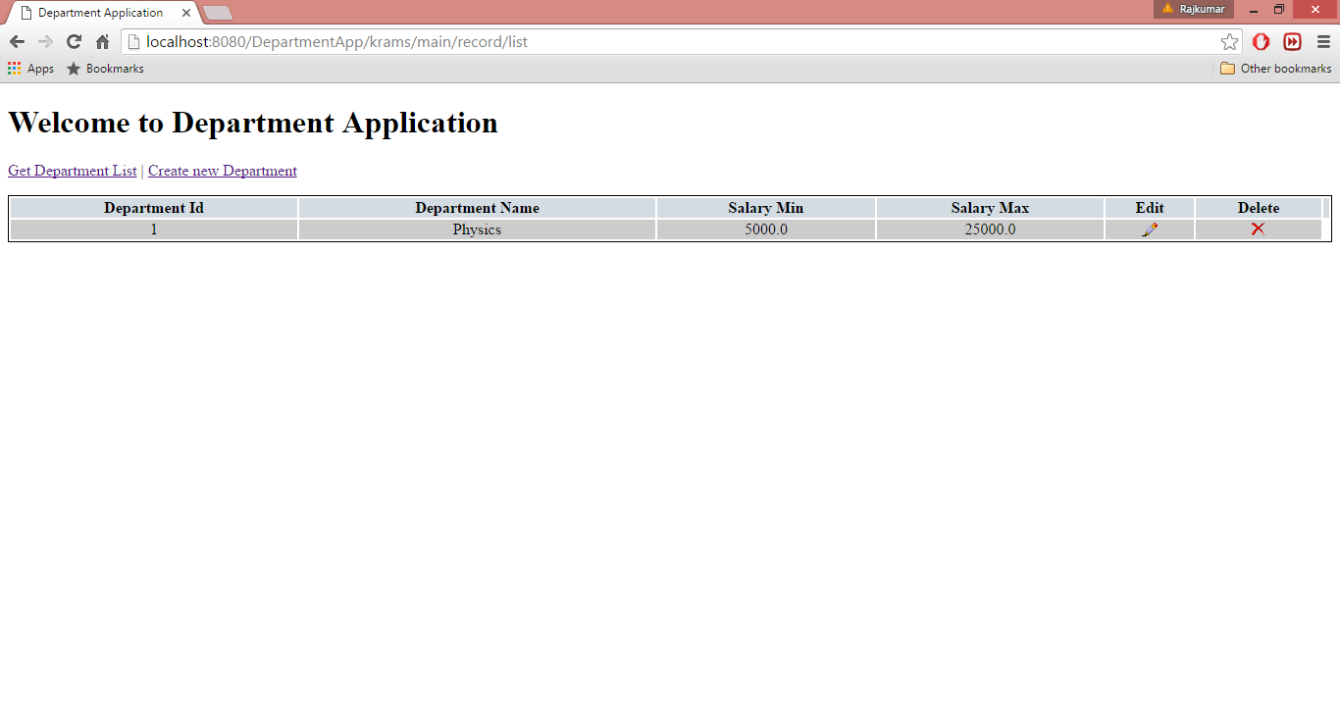

Step:5 Select Edit option to edit and validate input fields.

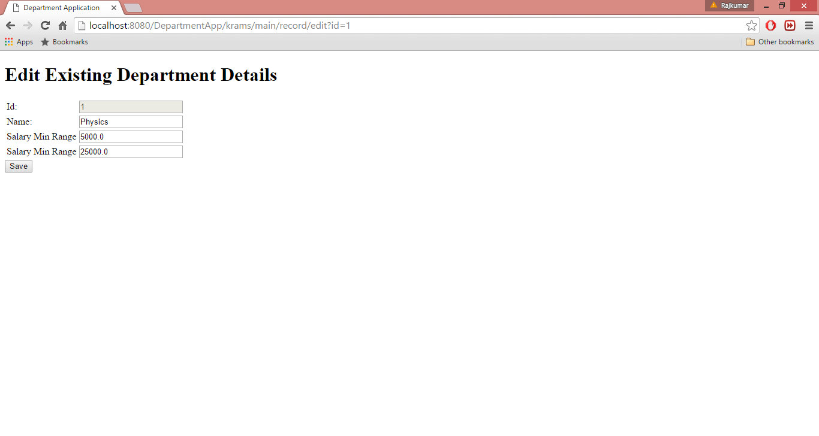

Step: 6 Validation on edit screen.

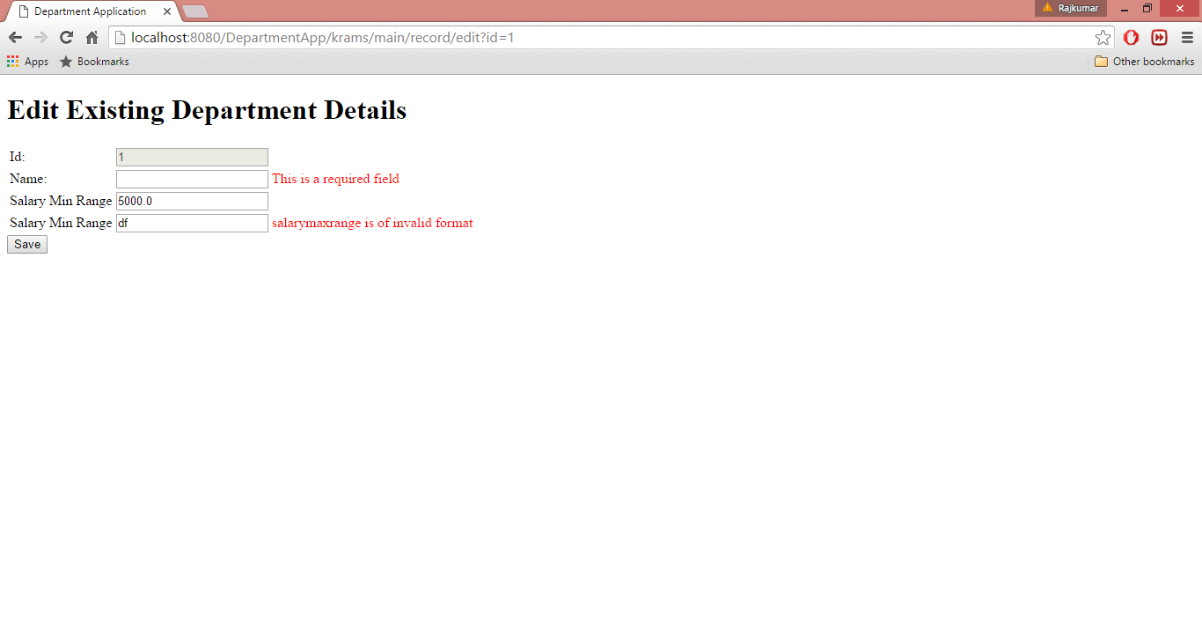

Step:7 Modified department details

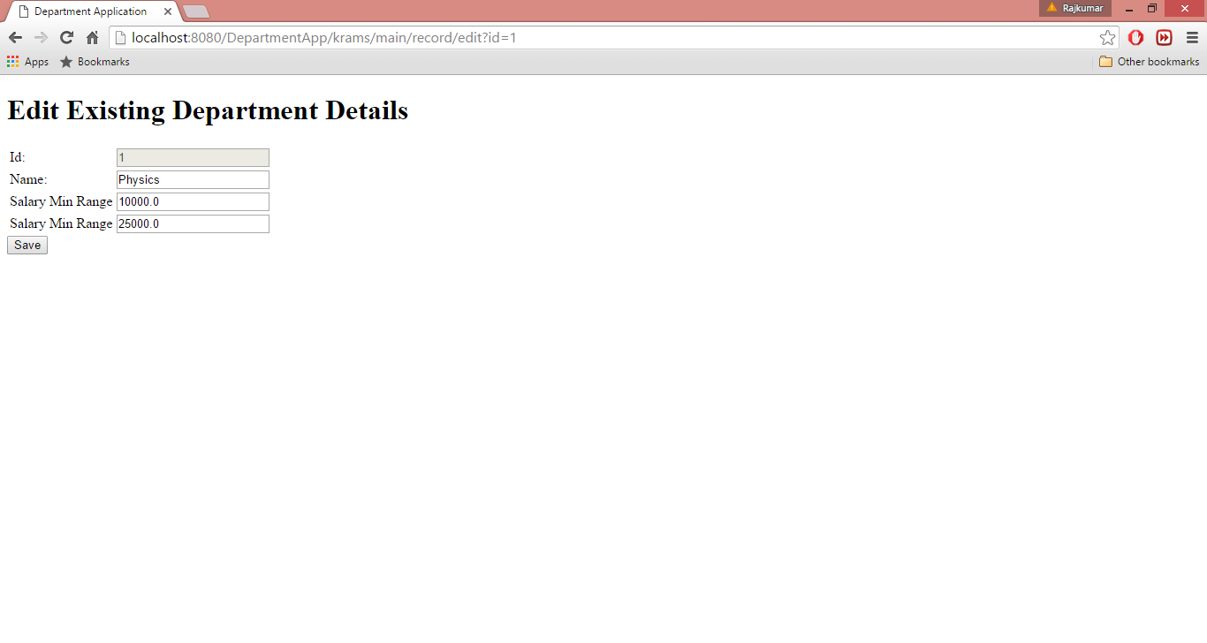

Step:8 Modified data display on the department detail screen

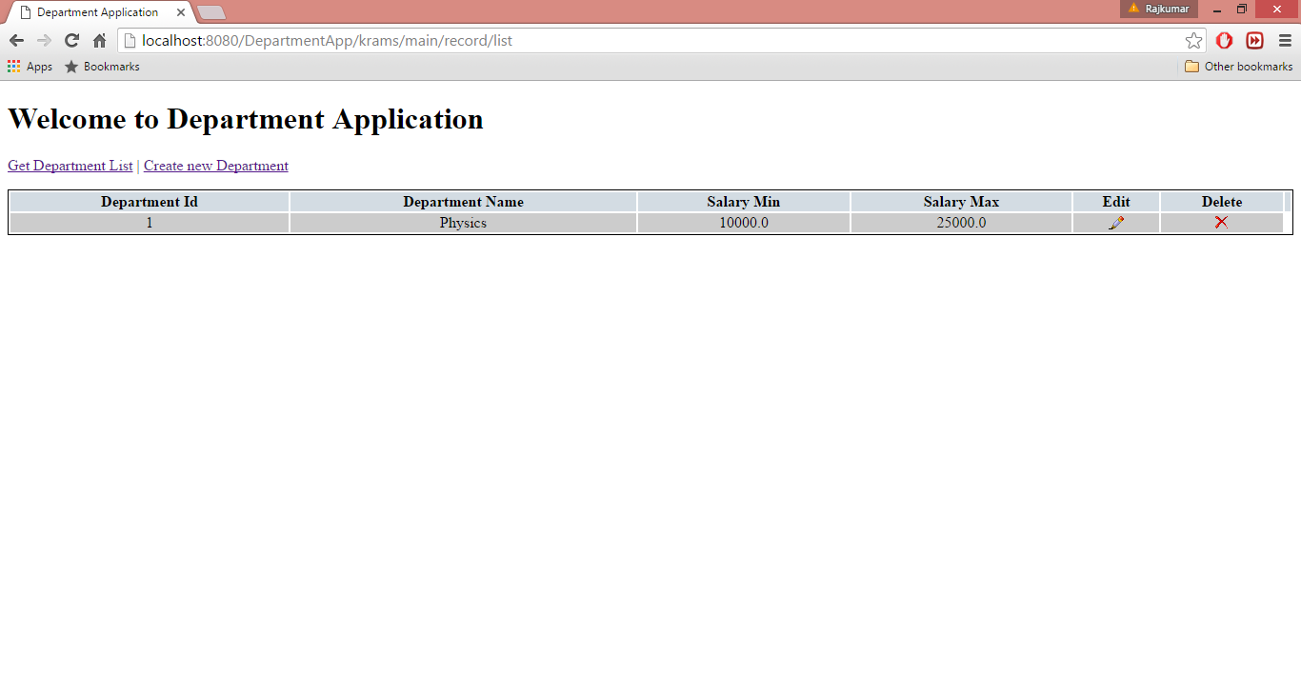

Step:9 Select option Delete to delete record and below screen display after deletion of records.

